Papers written by
Australian Maths Software

SEMESTER ONE
MATHEMATICS APPLICATIONS
REVISION 2

UNIT 3

2016

SOLUTIONS

SECTION ONE
1. (4 marks)
(a) There is no cause and effect relationship between the per capita cheese
consumption and the number of people who died tangled in their bed sheets.
✓✓ (2)

(b) Maybe the underlying cause for both in the increase in population so both
figures rose together.
The cause of both is most likely unrelated. Maybe the advertisments for cheese
increased cheese consumption at the same time young people no longer lived in the
same city as their parents who ended up tangled in their sheets.
✓✓ (2)
Accept anything sensible.
2. (7 marks)
✓

(a) The residuals are not randomly distributed about the regression line,
so a linear fit is not appropriate.
In the graphed data, the points in the middle are below the
✓

regression line and the points at the ends on both the left and right sides
are above the regression line.
This suggests a parabolic (or exponential) fit is better.
✓

The lack of randomness of the residuals suggest a linear fit is not appropriate.
The sample size is very small so any fit may not be valid. (3)
(b) (i)
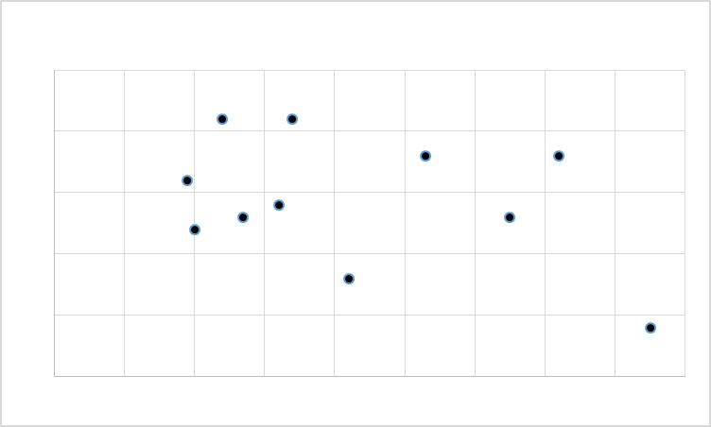
Number of goals kicked by the Eagles
Number of road accidents on the day of the match
✓

✓

Answers will vary (2)

(ii)
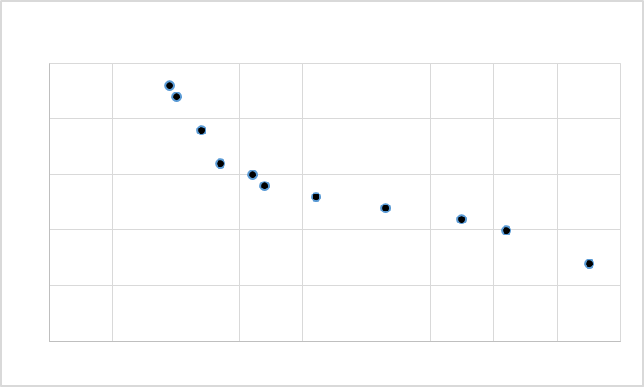
Number of kms driven
Number of litres left in the tank
✓

✓

Answers will vary (2)

3. (8 marks)
(a) 20, 16, 12, 8 ✓✓ (2)
(b) 1 000, 1 100, 1 210, 1 331 ✓✓✓ (3)
(c) 1, 2, 4, 7 ✓✓✓ (3)

4. (13 marks)
(a) (i) The graph is not simple because it contains a loop. ✓ (1)
A simple graph contains no loops or multiple edges.

(ii) The degree of vertex D is 4. ✓ (1)

(iii) BEFB or BCDEB or BCDEFB ✓ (1)

(iv) The graph is a semi-Eulerian graph because all the paths can be traced
but the starting and finishing points must occur at the two odd vertices
i.e. at A and E. ✓✓ (2)

(b) (i) Closed trail BAPQB or GEFG etc (there are 7 of them) ✓✓ (2)

(ii) Subgraph BAPQ
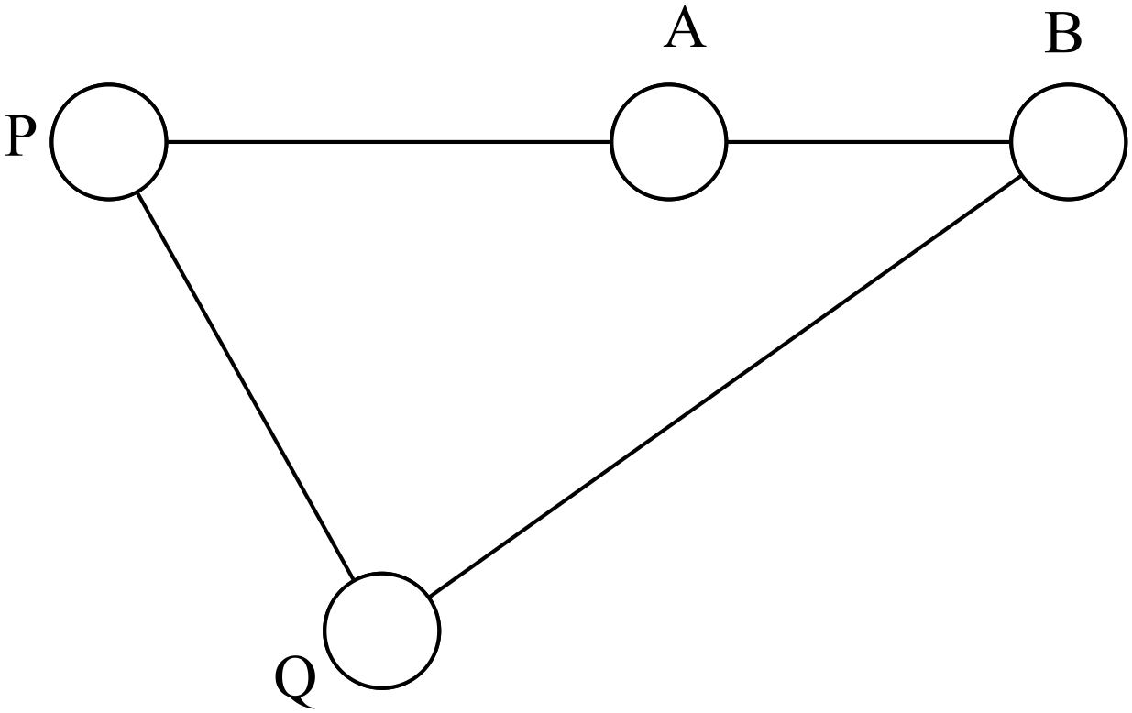
A semi-Hamiltonian path is BAPQ (or APQB etc ) ✓✓ (2)

(iii) The bridge is BG ✓ (1)

(c) A bipartite graph is one whose vertices are in two disjoint sets as in A. ✓✓
An element of one set is not mapped to an element of the same set.
In B there is a mapping among the set on the right which means the graph is not
bipartite. ✓ (2)

5. (12 marks)

(a)

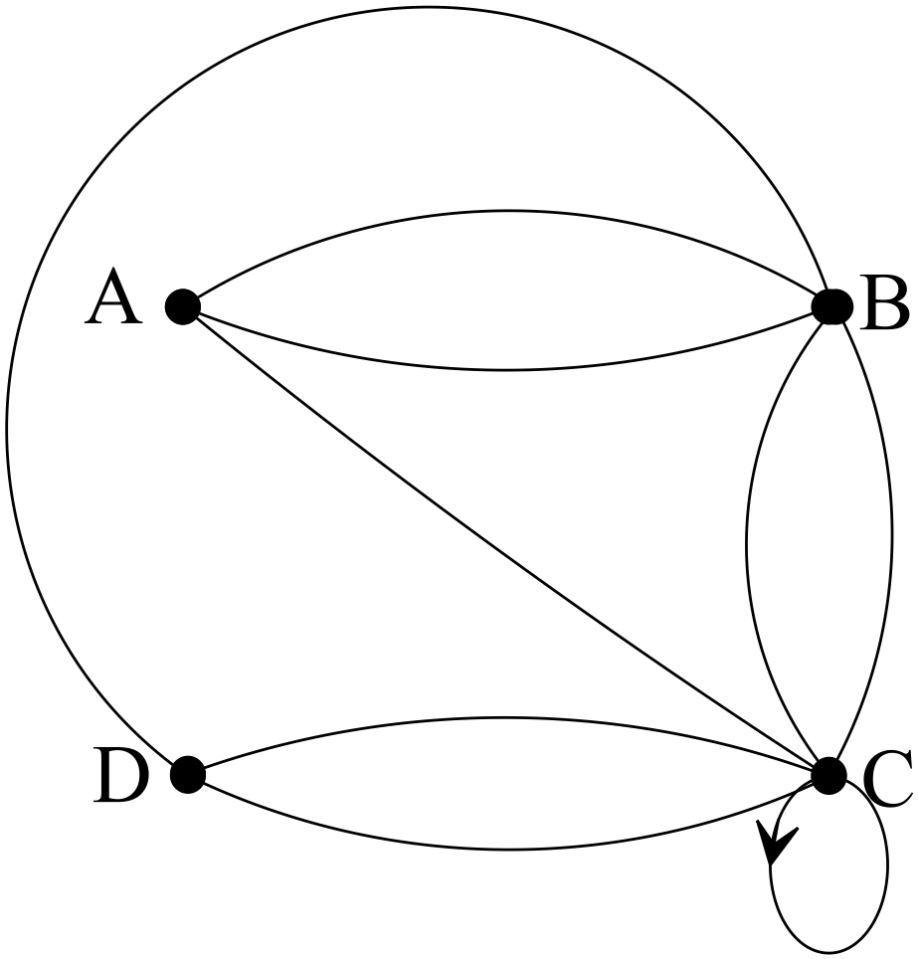
✓✓✓ (3)

(b) C ✓ (1)

(c) B and C ✓✓ (2)

(d) (i) 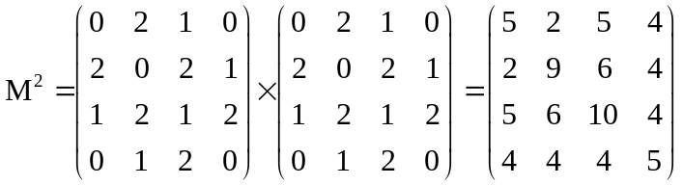✓✓✓✓ -1/error (4)

(ii) Yes, A had had no connection with D. ✓ (1)

6. (8 marks)
(a) 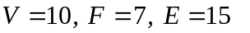✓✓✓ (3)
✓
(b) 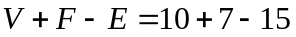
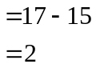
✓
Euler’s rule works therefore the figure is planar. ✓ (3)

(c)

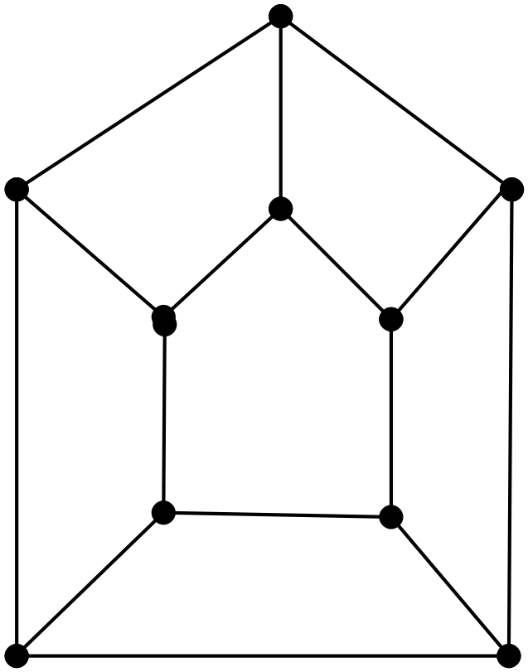

✓✓ (2)

END OF SECTION ONE
SECTION TWO

7. (4 marks)
(a) Simple graph as there are no loops or multiple edges. ✓
Directed graph as there are directional arrows on the arcs. ✓ (2)

(b)
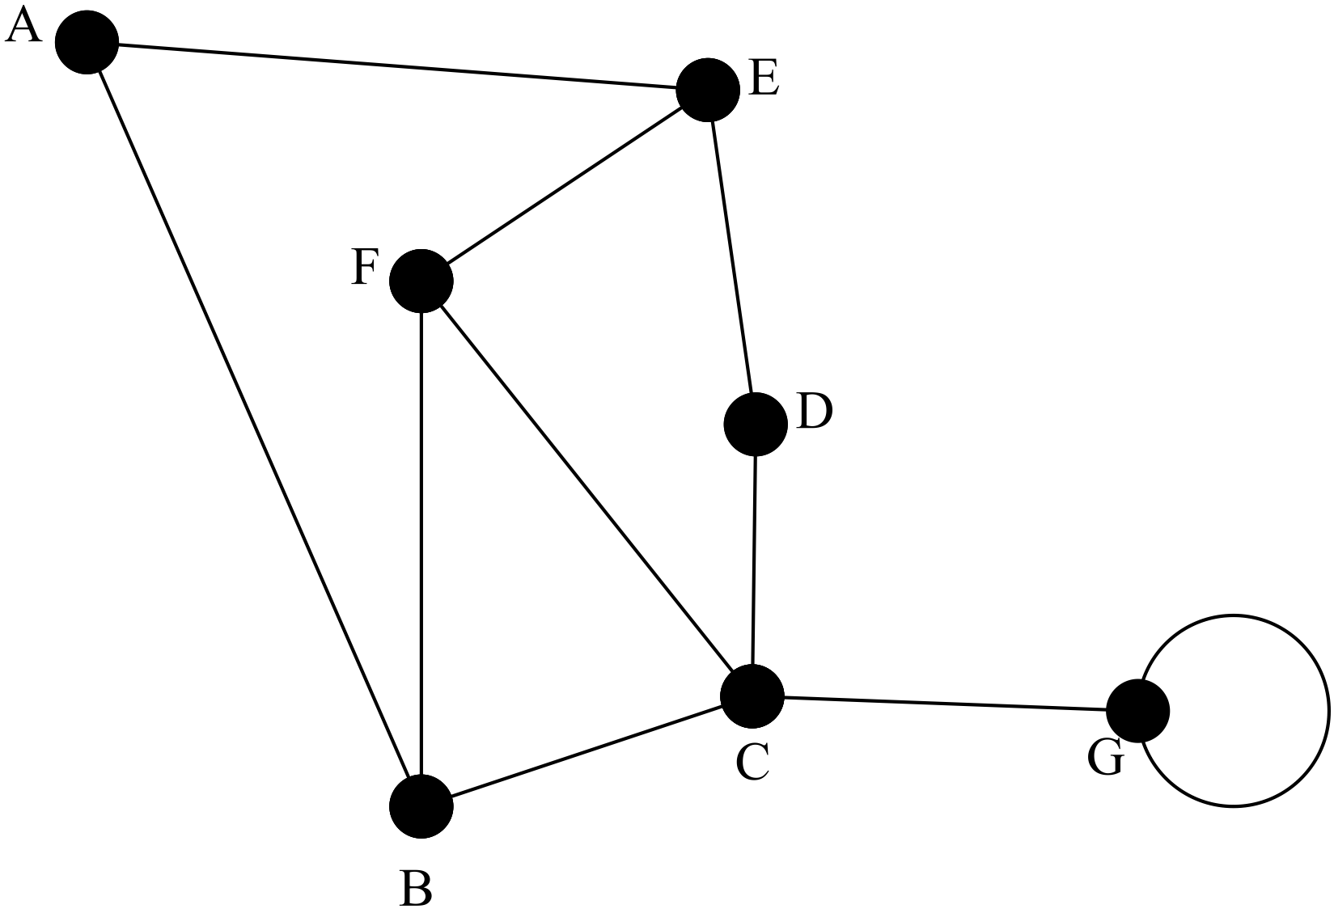
Degree 4

✓

Loop

✓

(2)
8. (27 marks)
(a) (i) There is a very weak, if any, relationship between the variables
temperature and heart rate. ✓✓ (2)

(ii) 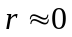 ✓ (1)

(b) (i) The relationship between age and height is positive, probably close to
linear and strong. ✓✓✓ (3)

(ii) The scatterdiagram would go from bottom left to top right. The points would
be close to a line with a positive gradient. ✓✓ (2)
(As you grow older between the ages of 2 and 15, you get taller!)

(iii) It is not valid to predict the height of an 18 year old as it would be
extrapolation. His age is outside the given data range. ✓✓ (2)

(iv) The response variable is weight. ✓
The explanatory variable is height. ✓ (2)

(v) 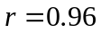 ✓✓ (2)
(vi) 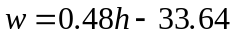 ✓✓✓ (3)

(vii) 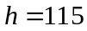
✓

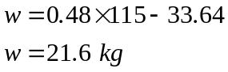
✓

The prediction is valid as in the given data range. ✓ (3)

(viii) The boy is about 6 years old. ✓✓ (2)

(ix) The correlation is very high but the residuals are not randomly distributed
and suggested a curve rather than a line. ✓✓ (2)
Maybe a parabolic function or maybe an exponential function.

(x) 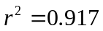 ✓
The unexplained variation between the data is only 8% ✓
It suggests a very strong relationship between the variables. ✓ (3)
9. (6 marks)
Temperature against Latitude: 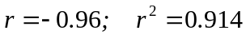
Number of daylight minutes against latitude: 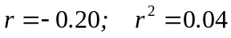
Number of daylight minutes against temperature: 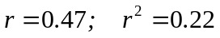
There is a strong linear relationship between temperature and latitude. Can predict
temperature from latitude. The unexplained variation is about 9%. ✓✓
There is a very poor relationship between latitude and the number of daylight minutes.
Cannot be used for prediction. 86% of unexplained variation. ✓✓
There is some relationship between temperature and the number of daylight minutes, but approximately 80% of variation is due to other factors. Not useful for prediction. ✓✓
(6)

10. (22 marks)

(a) (i) 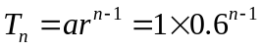 ✓ (1)

(ii) 0.6 m ✓ (1)

(iii)
Year n | Annual Growth
1 | 1 m
2 | 0.6 m
3 | 0.36 m
4 | 0.216 m
5 | 0.1296

✓✓ (2)

(iv) B ✓ (2)

(v) 1+0.6+0.36 = 1.96 m ✓ (1)

(b) (i) 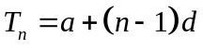
✓

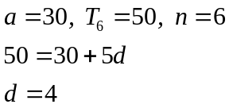
✓

✓

(3)
✓

(ii) 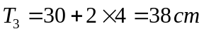
✓

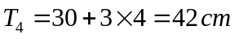 (2)

(iii) 240 cm ✓✓ (2)
(c) (i)
✓

✓

✓

Beginning of year | Value
2015 | $20 000
2016 | $16 000
2017 | $12 800
2018 | $10 240

(3)
(ii)
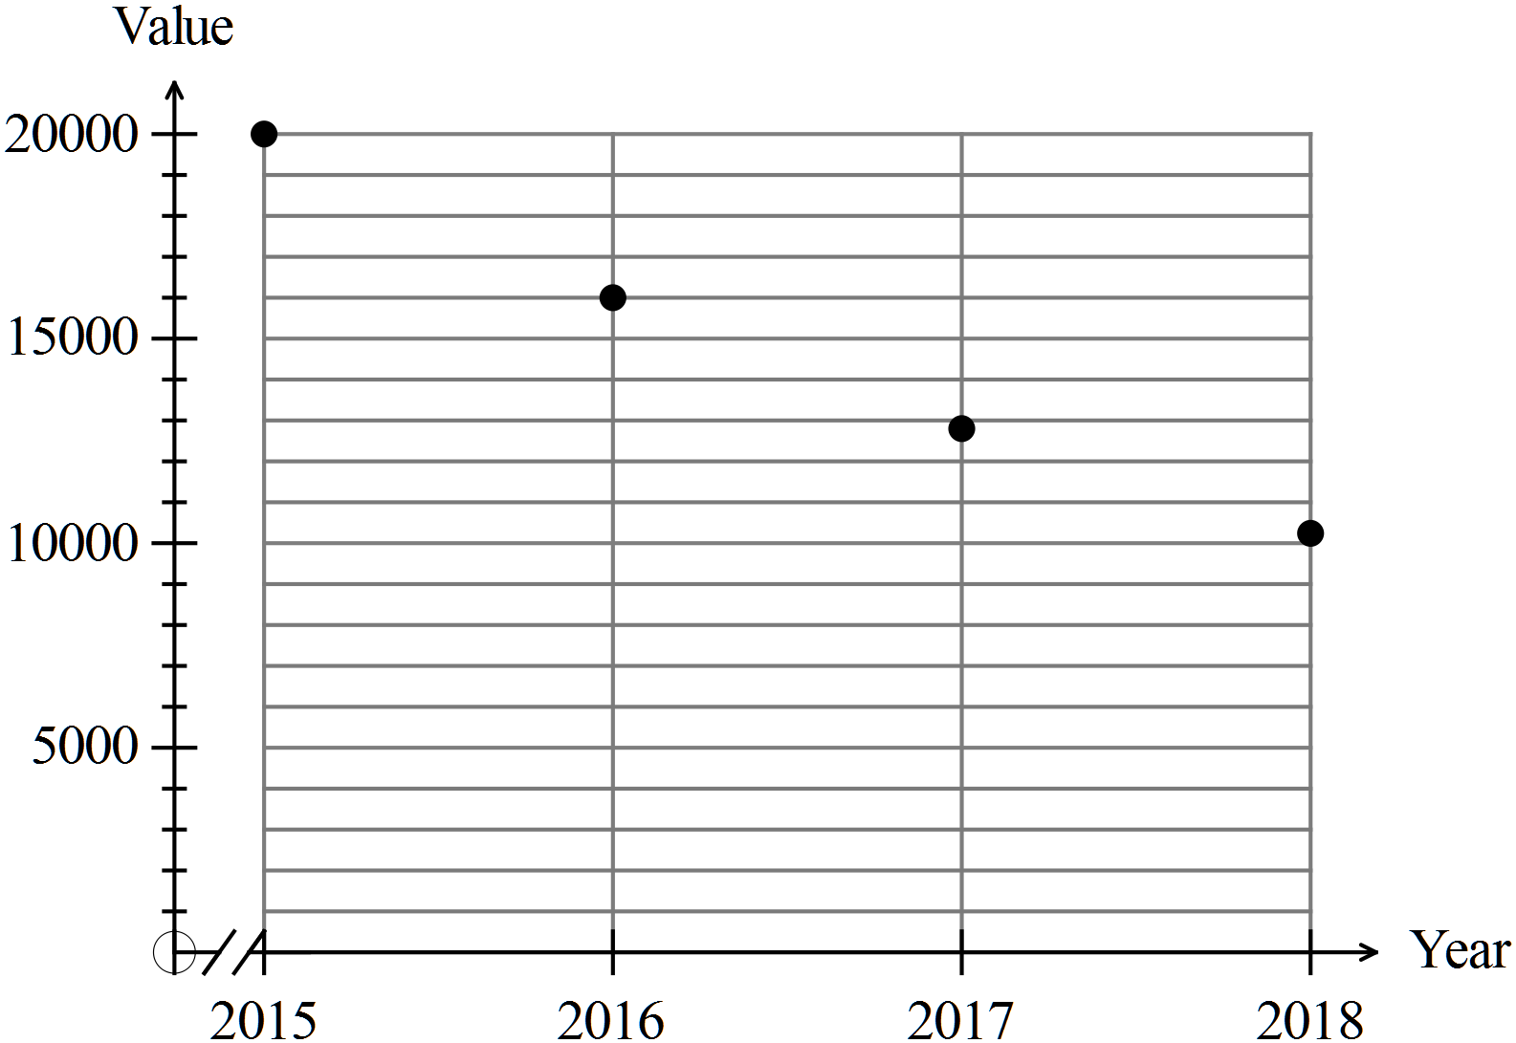
✓

✓✓

(2)

(iii) 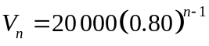
✓

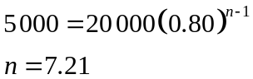
✓

Sometime during 2022 the car will be worth less than $5000. (3)
✓

11. (6 marks)

(a) ✓ (1)
(b) ✓ (1)
(c) 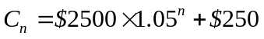 ✓ ✓ (1)
(d) 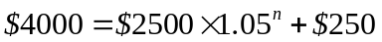 ✓
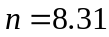 ✓
Mrs Jones could afford the first eight years, but not the 9th.
This would occur in 2023. ✓ (3)

12. (5 marks)

(a) decrease ✓ (1)
(b) $1000 ✓ (1)

(c)
Owed | Costs | Payment | Owed at end of year
10 000 | 1 000 | 1 500 | 9 500
9 500 | 1 000 | 1 500 | 9 000
9 000 | 1 000 | 1 500 | 8 500
✓✓
✓

After three years Judy owes $8500. ✓ (3)

13. (11 marks)

(a) (i)
 | Live in electorate | Do not live in the electorate
Resign | 20% | 80% | 100%
Not resign | 40% | 60% | 100%

✓✓✓
✓

(3)

(ii) Of those that want the politician to resign, only 20% of the people live in
the electorate. Of those who didn’t want the politician to
resign, 40% of them lived in the electorate.
This suggests the attitude of those that may know the local politician
may be biased towards him. ✓ ✓

It does imply further investigation should be done! (2)

(b) (i)
 | Live in electorate | Do not live in the electorate
Resign | 60% | 80%
Not resign | 40% | 20%
 | 100% | 100%
✓✓✓

(3)
(ii) A larger proportion of people who live outside the electorate want the
politician to resign than those who live inside the electorate.
✓✓ (2)

(iii) The result implies the politician is/has been popular for some reason
and the constituents show some resistance to the resignation in spite of
the misuse of public funds. ✓ (1)

Anything sensible

14. (13 marks)

(a) (i) The graph is Eulerian as a circuit exists that visits each path
exactly once.
This is because all vertices have degree 6.
Graphs with all even vertices can be traversed, so the graph is
Eulerian. ✓✓ (2)

(II) The graph is Hamiltonian as a circuit exists that visits each vertex
exactly once. ✓✓ (2)

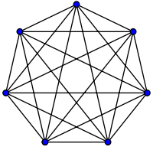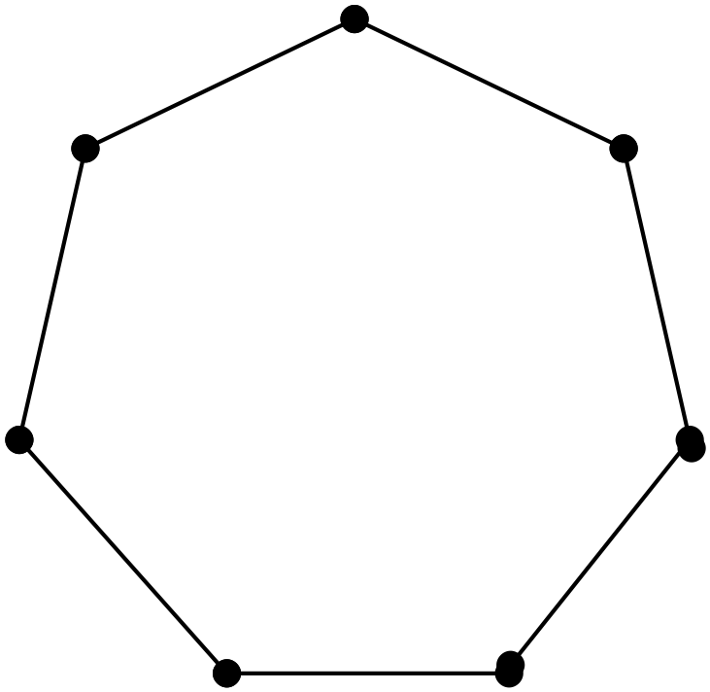

(iii) Semi-Eulerian as all edges can be traversed but the starting and ending
points are different. i.e. at A and C
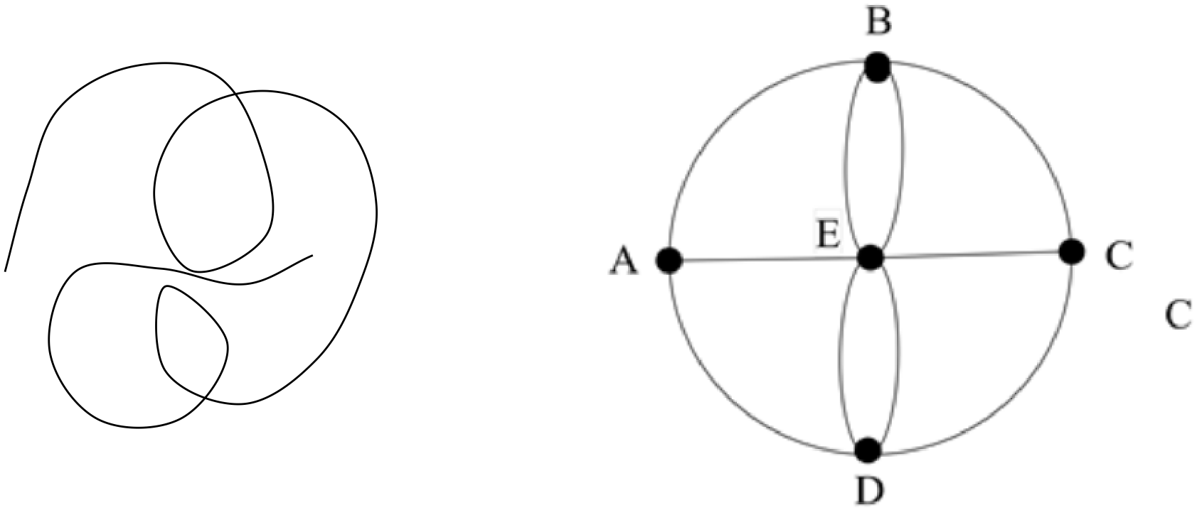

✓✓ (2)

(iv) Semi-Hamiltonian as every vertex can be visited just once but the starting and
finishing points are different. . ✓✓

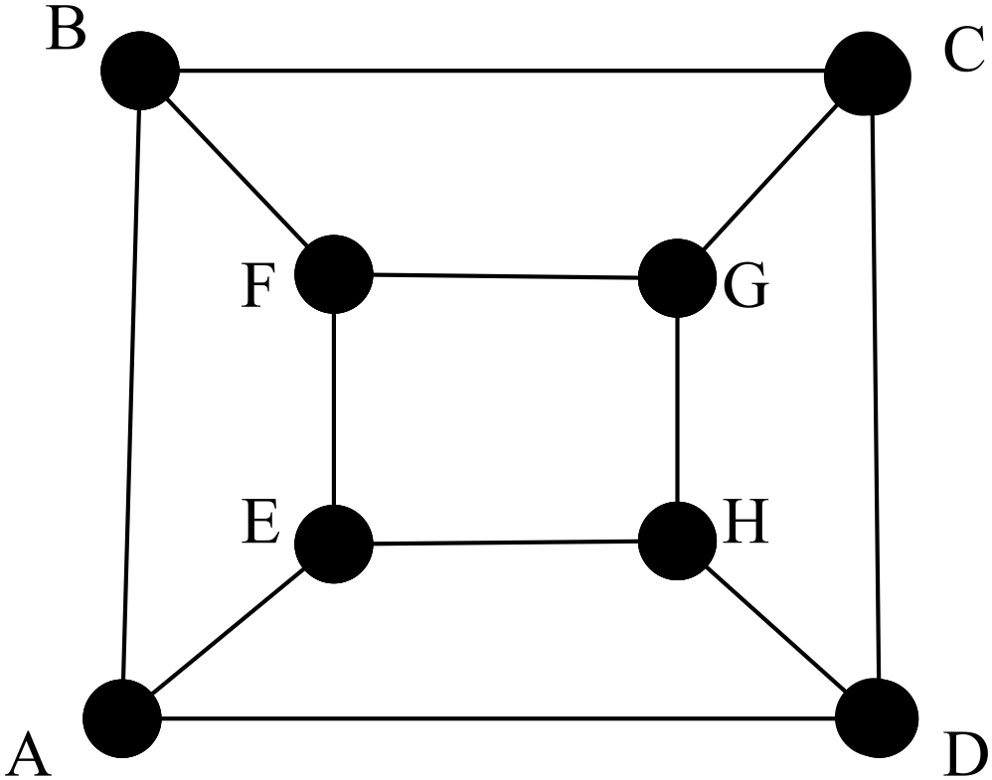

For example ABCDHGFE (2)

(b) (i) There are more than 2 odd nodes so it is not possible to run over a series of
paths from one point to another running over every path exactly once. ✓✓
(2)

(ii)
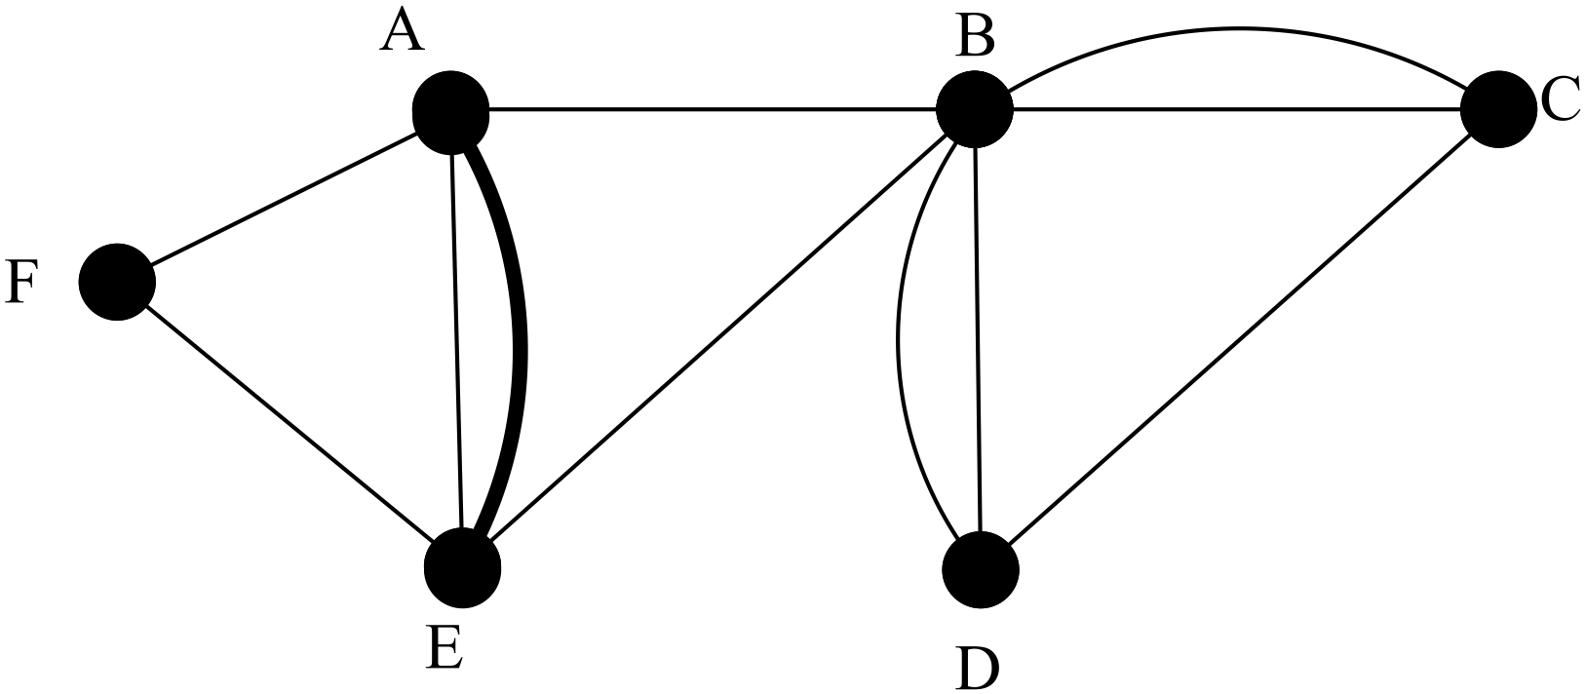
✓

NB Any two of the vertices A,E, D,C can be joined. (1)

(iii) The starting and finishing points will be the two vertices NOT used in (ii) of
A,E,D,C
In this case, the starting and finishing points are D and C as I have joined AE.
✓✓ (2)

15. (4 marks)
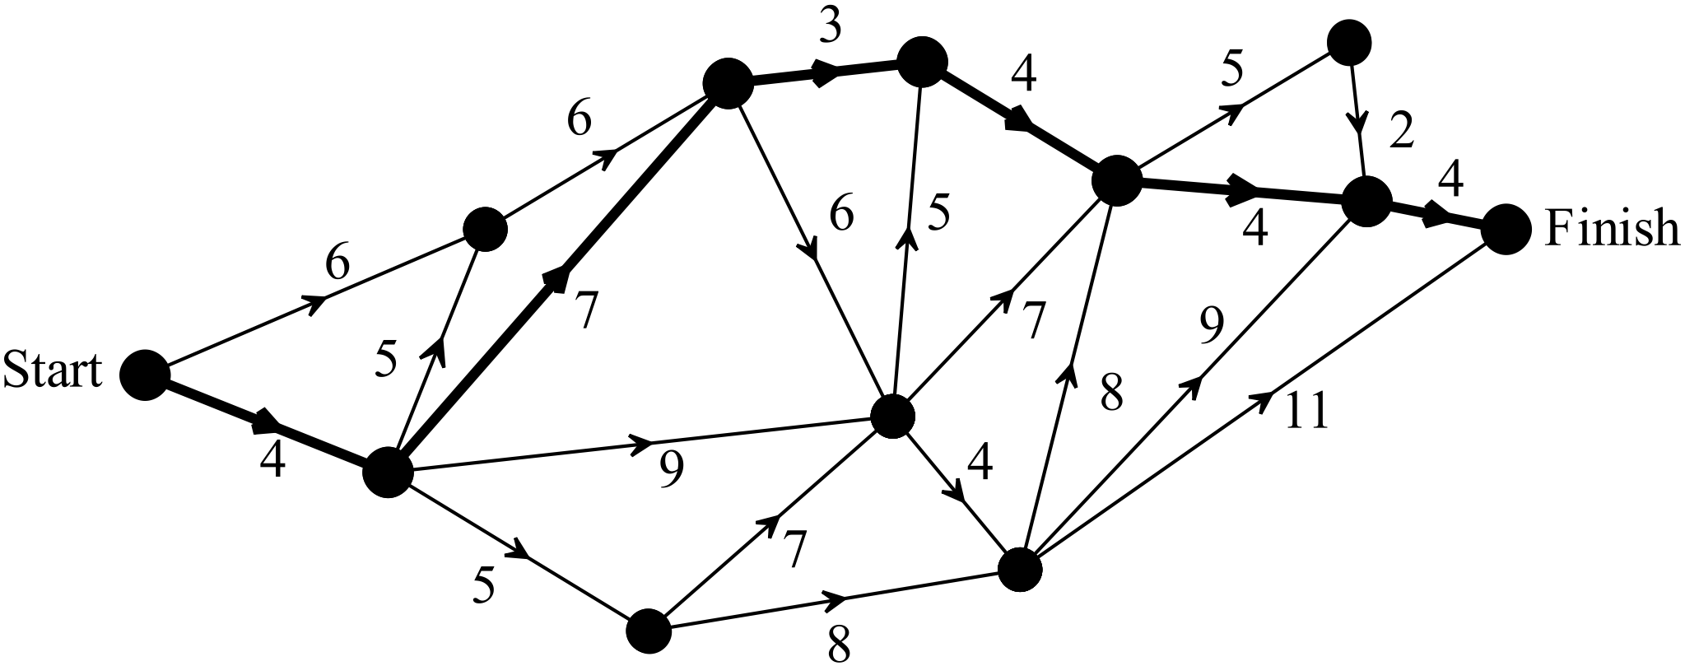

✓✓✓

The shortest distance is 26 units. ✓ (4)

END OF SECTION TWO

